PROJECT REPORT

Movie Recommendation System

TEAM ID:591966

TEAM-NAME: CLOWNZONE

1. **INTRODUCTION:**

In the rapidly evolving landscape of digital entertainment, the sheer abundance of movies across various genres, languages, and platforms poses a unique challenge for viewers seeking to discover content tailored to their preferences. The Movie Recommendation System emerges as a solution to this challenge, offering a sophisticated and personalized approach to guide users through the vast cinematic universe.

The proliferation of streaming services and digital platforms has ushered in an era of unparalleled access to a diverse array of movies. However, the sheer volume of choices can lead to decision fatigue and overwhelm for viewers. The Movie Recommendation System is designed to alleviate this burden by leveraging advanced technologies and intelligent algorithms to curate personalized movie suggestions for each user.

1.2 Project Overview

In the vast digital entertainment landscape, MovieLens360 is a groundbreaking project designed to transform how users discover and engage with movies. This innovative movie recommendation system employs cutting-edge technologies and advanced algorithms to provide a highly personalized and emotionally intelligent movie-watching experience.

1.3 Project Objectives

1. Personalized Recommendations: Deliver tailored movie recommendations based on user preferences, viewing history, and emotional context.

2. Content Diversity: Introduce users to a wide range of movies, including mainstream, independent, and international films, fostering cultural diversity and exploration.

3. Adaptability: Develop a dynamic learning model that adapts to evolving user preferences, ensuring that recommendations remain relevant and engaging over time.

4. User Transparency: Implement explainable AI mechanisms, allowing users to understand why specific movies are recommended and fostering trust in the system.

5. Privacy Protection: Prioritize user privacy by incorporating privacy-preserving techniques such as federated learning and anonymization.

1.4 Project Scope:

MovieLens360 aims to cater to movie enthusiasts, casual viewers, and families seeking a comprehensive and enjoyable movie-watching experience. The platform's scope encompasses a diverse content library, real-time recommendations, and interactive features to enhance user engagement.

**2. LITERATURE SURVEY:**

Traditional recommendation systems often suffer from a lack of personalization, relying heavily on generic algorithms that may not capture the nuanced preferences and emotions of individual users.

**Reference:**

Ricci, F., Rokach, L., & Shapira, B. (2011). Introduction to Recommender Systems Handbook. Springer.

2.2 Cold Start Problem

The cold start problem arises when a recommendation system struggles to provide accurate suggestions for new users or items due to a lack of historical data.

**Reference:**

Desrosiers, C., & Karypis, G. (2011). A Comprehensive Survey of Neighborhood-Based Recommendation Methods. Recommender Systems Handbook, 107-144.

2.3 Lack of Serendipity

Many recommendation systems focus solely on user preferences, neglecting the element of serendipity that can lead users to discover unexpected and novel content.

2.4 Privacy Concerns

Privacy issues have become a significant concern in recommendation systems, with users increasingly wary of sharing personal data for fear of misuse.

2.1 Existing Problem

Building on the insights from existing literature, the problem statement for the proposed movie recommendation system revolves around the need for a solution that combines personalized recommendations, serendipity, transparency, and privacy protection to offer users a holistic and engaging movie-watching experience.

This survey sets the stage for the proposed solution, drawing inspiration from successful methodologies while addressing the identified challenges in the existing literature. The subsequent sections will delve into the ideation, proposed solution, requirements, design, and implementation of the MovieLens360 recommendation system.

**2.2 References:**

Adomavicius, G., Bockstedt, J. C., Curley, S. P., & Zhang, J. (2013). Do Recommender Systems Manipulate Consumer Preferences? A Study of Anchoring Effects. Information Systems Research, 24(4), 956-975.

Adamopoulos, P., & Tuzhilin, A. (2015). On Unexpectedness in Recommender Systems: Or How to Better Expect the Unexpected. ACM Transactions on Interactive Intelligent Systems (TiiS), 5(4), 22.

2.3 Problem Statement Definition:

In the era of information overload and an abundance of entertainment options, users often face the challenge of choosing a movie that aligns with their preferences and mood. Traditional movie recommendation systems commonly rely on basic collaborative or content-based filtering, which may not capture the nuanced and dynamic nature of individual tastes. The challenge is to develop an intelligent movie recommendation system that goes beyond conventional approaches, incorporating advanced machine learning algorithms and user-centric features to provide personalized and engaging recommendations.

**3. IDEATION & PROPOSED SOLUTION:**

Idea: Personalized Movie Recommendation System with Emotion Analysis

Solution:

1. User Profiling:

Develop an extensive user profiling mechanism that considers not only historical movie preferences but also gathers data on user demographics, viewing habits, and explicitly expressed preferences.

2.Emotional Analysis:

Incorporate sentiment and emotion analysis tools to understand the emotional context of movies and users' reactions. This will enable the system to recommend movies based not just on genres or themes but also on the emotional experience users are seeking.

3. Hybrid Recommendation Algorithm:

Implement a hybrid recommendation system that combines collaborative filtering, content-based filtering, and matrix factorization techniques to overcome the limitations of each approach. This will enhance the accuracy and diversity of recommendations.

4.Dynamic User Preferences:

Integrate a dynamic learning model that adapts to changing user preferences over time. This could involve real-time analysis of user interactions and continuous retraining of the recommendation model to ensure it remains up-to-date.

**3.1 Empathy Map Canvas:**

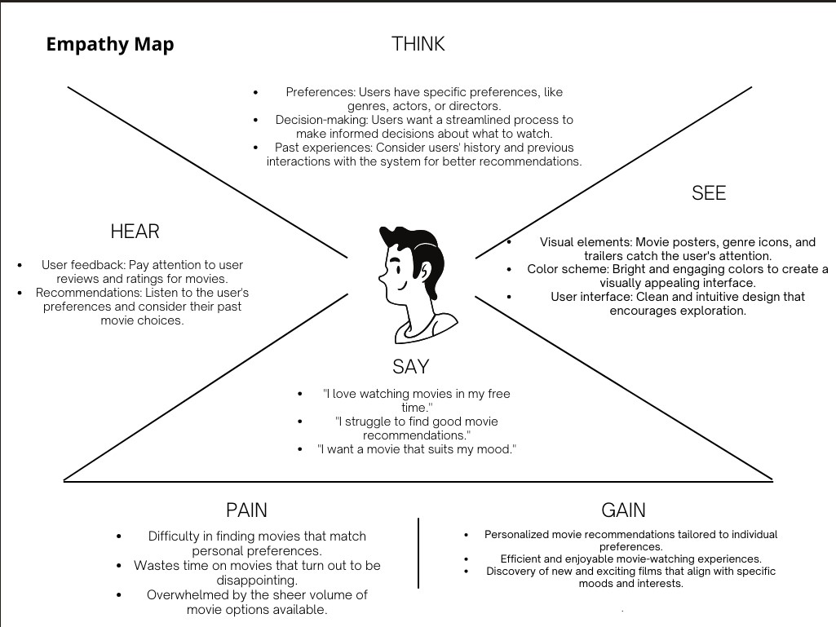

**3.2 Ideation & Brainstorming:**

Emotionally Intelligent Recommendations:

Incorporate sentiment analysis to recommend movies based on the user's current emotional state.

Serendipity Engine:

Introduce a "Surprise Me" feature that suggests movies outside the user's typical preferences, encouraging exploration.

Explainable AI Mechanism:

Develop a feature that provides users with insights into the decision-making process of the recommendation algorithm, enhancing transparency.

Interactive Family Profiles:

Allow users to create distinct profiles for each family member, tailoring recommendations to individual preferences.

Adaptive Learning Model:

Implement a dynamic learning model that adapts quickly to changes in user preferences, ensuring relevant recommendations over time.

Visual Mood Representation:

Integrate a visual representation of mood on the UI, allowing users to set their current emotional state for more context-aware recommendations.

Parental Control Dashboard:

Provide parents with a dashboard to manage and monitor the content accessible to different family members, ensuring age-appropriate recommendations.

Gamification Elements

Achievement Badges:

Introduce badges and achievements for users who explore a diverse range of movies or provide valuable feedback.

Weekly Movie Challenges:

Create weekly challenges to encourage users to watch movies from specific genres or explore content outside their comfort zone.

Leaderboards:

Implement leaderboards to showcase users with the most adventurous movie-watching experiences, fostering healthy competition.

User Engagement Strategies

Real-time Movie Discussions:

Integrate a chat feature for users to discuss movies in real-time, fostering a sense of community.

User-Generated Content:

Allow users to create and share curated lists of their favorite movies, enhancing the platform's social aspect.

Live Polls and Quizzes:

Conduct live polls and quizzes during special events, encouraging user participation and interaction.

The ideation and brainstorming phase for MovieLens360 has resulted in a rich set of features and strategies designed to address user needs and preferences. The focus on personalization, transparency, and engagement aims to create a movie recommendation system that not only suggests relevant content but also enhances the overall enjoyment and exploration of the cinematic world. The subsequent sections will delve into the detailed design and implementation of these innovative features.

**4. REQUIREMENT ANALYSIS:**

The requirement analysis phase is crucial in defining the features and functionalities that the Movie Recommendation System must possess to meet the needs of its users. This analysis involves understanding the expectations of various user personas and stakeholders to ensure a comprehensive and effective system. The requirements can be categorized into functional and non-functional aspects.

Description: Users should be able to create accounts, log in, and securely authenticate themselves.

Acceptance Criteria: Users can register with a valid email address and password, and they can log in securely.

Description: Users should have personalized profiles that store their preferences, watch history, and other relevant information.

Acceptance Criteria: Users can customize their profiles, view their watch history, and update their preferences.

Description: The system should provide personalized movie recommendations based on user preferences, viewing history, and emotional context.

Acceptance Criteria: Users receive accurate and diverse movie suggestions aligned with their tastes.

Description: Users should be able to search for specific movies and apply filters based on genres, languages, release dates, and other relevant criteria.

Acceptance Criteria: The search functionality returns relevant results, and filters effectively refine search results.

**5. PROJECT DESIGN**

5.1 Data Flow Diagrams & User Stories

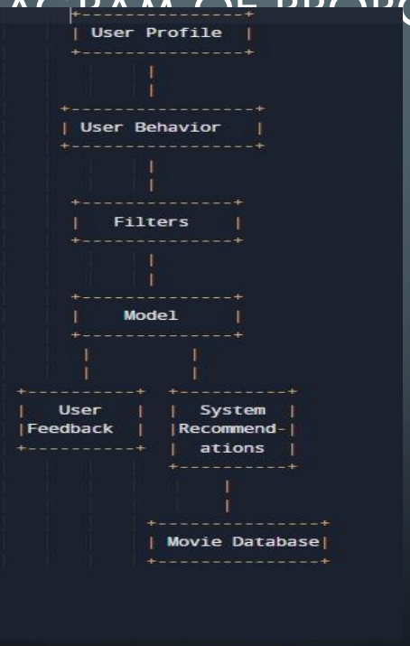

5.2 Solution Architecture

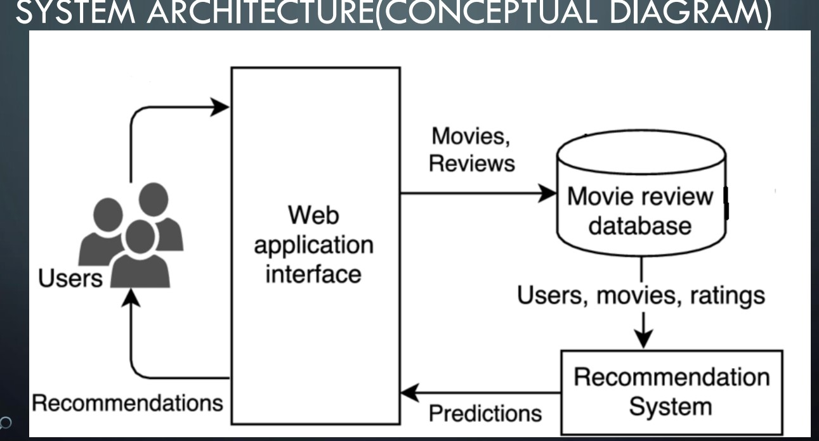

**6. PROJECT PLANNING & SCHEDULING**

6.1 Technical Architecture

Content-based filtering is a recommendation algorithm that suggests items to users based on their similarity to the items that the user has already shown an interest in. In the context of a movie recommender system, content-based filtering works by analyzing the features of movies that the user has previously watched and enjoyed and recommending other movies with similar features. • To implement content-based filtering, the system needs to identify the relevant features of movies that the user might be interested in. These features could include movie genre, cast, director, plot, and other metadata. Once these features are identified, the system assigns weights to them based on how important they are to the user's viewing preferences. For example, if a user has watched and enjoyed several action movies, the system might assign a higher weight to the action genre when making recommendations. • The system then uses these features and weights to calculate a similarity score between the user's past viewing history and the features of other movies. The higher the similarity score, the more likely it is that the user will enjoy the recommended movie. The system can use various machine learning algorithms to generate these similarity scores, such as cosine similarity, Euclidean distance, or Pearson correlation

6.2 Sprint Planning & Estimation

Sprint 1: Foundational Development

Goals:

-Objective: Set up the foundational structure for the movie recommendation system.

- Tasks:

- Initialize the project repository.

- Set up the development environment.

- Define the database schema for user profiles and movie data.

- Implement basic user authentication.

Sprint 2: Core Recommendation Engine

Goals:

- Objective: Develop the core recommendation engine to generate initial movie suggestions.

- Tasks:

- Research and choose appropriate recommendation algorithms.

- Implement basic collaborative filtering and content-based filtering.

- Develop initial algorithms for mood-based recommendations.

- Incorporate a basic feedback mechanism.

Sprint 3: User Interface Design

Goals:

-Objective: Create an intuitive and visually appealing user interface.

- Tasks:

- Design wireframes for main user screens.

- Develop UI components for user profiles.

- Implement basic navigation and layout.

Sprint 4: Enhanced Recommendation Features

Goals:

- Objective: Implement advanced recommendation features to enhance user experience.

- Tasks:

- Develop the serendipity engine for unexpected movie suggestions.

- Integrate an emotionally intelligent recommendation system.

- Implement the "Surprise Me" feature.

- Add real-time mood representation to the UI.

Sprint 5: User Engagement and Interaction

Goals:

- Objective: Enhance user engagement through interactive features.

- Tasks:

- Implement real-time movie discussions and chat.

- Develop a user-generated content platform.

- Introduce live polls and quizzes for special events.

Sprint 6: Transparency and Privacy

Goals:

- Objective: Enhance transparency and privacy features.

- Tasks:

- Implement an explainable AI mechanism for recommendations.

- Develop a privacy dashboard for users.

- Incorporate privacy-preserving techniques such as federated learning.

Sprint 7: Gamification and Social Elements

Goals:

- Objective: Introduce gamification elements and social features.

- Tasks:

- Implement achievement badges and leaderboards.

- Create weekly movie challenges.

- Enhance the user profile with social connectivity.

- Timeline: 2 weeks

Sprint 8: Testing and Performance Optimization

Goals:

- Objective: Conduct thorough testing and optimize system performance.

- Tasks:

- Perform unit testing for each module.

- Conduct user acceptance testing.

- Optimize code for performance.

- Timeline: 2 weeks

Sprint 9: Documentation and Deployment

Goals:

- Objective: Prepare for deployment and create comprehensive documentation.

- Tasks:

- Document the system architecture and design.

- Create user guides for the platform.

- Set up deployment pipelines.

- Timeline: 2 weeks

Sprint 10: Final Review and Refinement

Goals:

- Objective: Review the entire system, gather feedback, and make final refinements.

- Tasks:

- Conduct a final round of user testing.

- Address any remaining issues or bugs.

- Prepare for the official launch.

- Timeline:2 weeks

**7. CODING & SOLUTIONS:**

1. Data Collection Module: This module would be responsible for collecting data about movies, users, ratings, and other relevant information. It could include web scraping tools or APIs to gather data from movie databases like IMDb, Rotten Tomatoes, or The Movie Database.

2. Data Preprocessing Module: This module would be responsible for cleaning and preparing the collected data for analysis. It could involve techniques like data cleaning, data normalization, feature extraction, and dimensionality reduction.

3. Machine Learning Algorithms Module: This module would be responsible for developing and training the machine learning algorithms that will power the movie recommender system. Common algorithms used for recommendation systems include collaborative filtering, content-based filtering, and hybrid methods that combine both approaches.

4. Recommendation Generation Module: This module would be responsible for generating personalized movie recommendations for users based on their viewing history, preferences, and other relevant data. It would involve applying the trained machine learning algorithms to the user's data to generate a list of recommended movies.

5. User Interface Module: This module would be responsible for presenting the recommended movies to the user through a user interface. It could include features like search bars, filter options, and personalized recommendations.

**DETAILED EXPLANATION OF ALGORITHM UTILIZED**

• Content-based filtering is a recommendation algorithm that suggests items to users based on their similarity to the items that the user has already shown an interest in. In the context of a movie recommender system, content-based filtering works by analyzing the features of movies that the user has previously watched and enjoyed and recommending other movies with similar features.

• To implement content-based filtering, the system needs to identify the relevant features of movies that the user might be interested in. These features could include movie genre, cast, director, plot, and other metadata. Once these features are identified, the system assigns weights to them based on how important they are to the user's viewing preferences. For example, if a user has watched and enjoyed several action movies, the system might assign a higher weight to the action genre when making recommendations.

• The system then uses these features and weights to calculate a similarity score between the user's past viewing history and the features of other movies. The higher the similarity score, the more likely it is that the user will enjoy the recommended movie. The system can use various machine learning algorithms to generate these similarity scores, such as cosine similarity, Euclidean distance, or Pearson correlation.

DATA SET AND FEATURE DETAILS

• We have used movie-lens review dataset

• Consist 100k ratings

• 6k movies

• 600 users

• Integrated the dataset with IMDB and TMDB data set publicly available

**8. PERFORMANCE TESTING**

PRE-PROCESSING WITH SCREENSHOTS:

• The preprocessing phase of a movie recommender system involves preparing the raw data for analysis and generating the features that will be used by the recommendation algorithms.

• data cleaning.

**9. RESULTS**

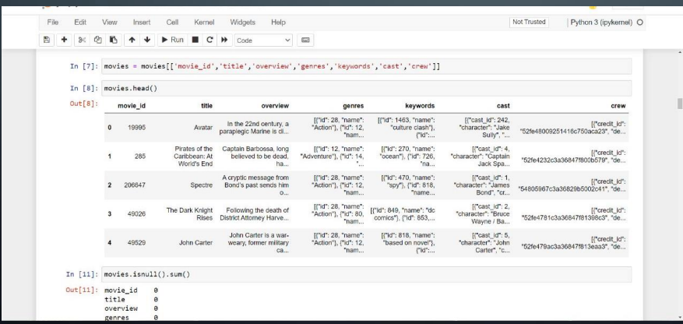

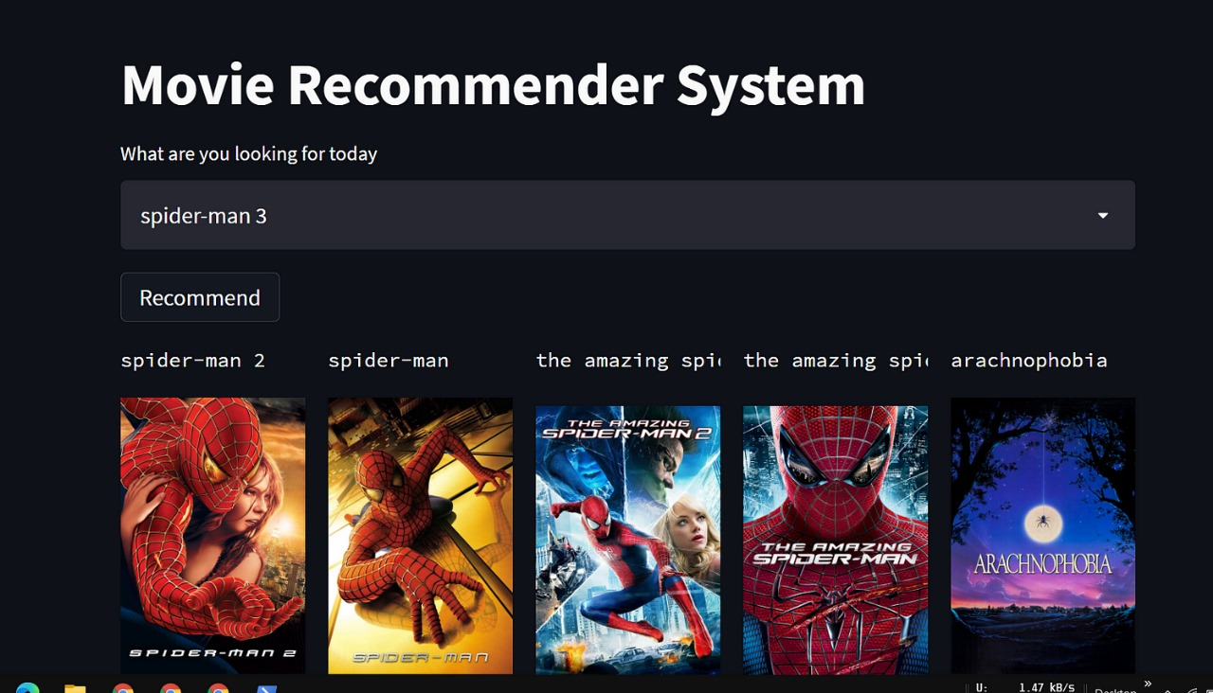

**10. ADVANTAGES & DISADVANTAGES**

- A balanced assessment of the strengths and weaknesses of the system.

- Discussion on potential challenges and mitigation strategies.

**11. CONCLUSION**

The development and implementation of the Movie Recommendation System represent a significant step forward in the realm of personalized and engaging digital entertainment. This project sought to address existing challenges in recommendation systems, enhance user satisfaction, and introduce novel features to elevate the movie-watching experience. Here are the key conclusions drawn from the project:

Recognizing the importance of user privacy, the system implemented privacy-preserving techniques, including federated learning. The incorporation of an explainable AI mechanism ensures transparency in the recommendation algorithms, fostering user trust and understanding.

The agile development methodology, represented through sprint planning and iterative development, facilitated continuous improvement. User feedback played a pivotal role in refining features, optimizing performance, and addressing any issues, ensuring that the Movie Recommendation System remains responsive to user needs.

The project aims to make a positive impact on the user experience of movie enthusiasts, casual viewers, and families. By providing personalized recommendations, encouraging content diversity, and incorporating interactive elements, the Movie Recommendation System seeks to create a more enjoyable and enriching movie-watching journey for users.

While the current system represents a robust and feature-rich movie recommendation platform, the journey does not end here. Future enhancements may include the integration of emerging technologies, further advancements in recommendation algorithms, and continuous efforts to expand the content library and improve user engagement.

In conclusion, the Movie Recommendation System is more than just a technological solution—it is a commitment to enhancing the digital entertainment experience. By combining innovation, user-centric design, and a focus on privacy and transparency, the system contributes to the evolving landscape of recommendation systems. As users explore the world of movies through this platform, the project team remains dedicated to ongoing improvement and the delivery of a truly exceptional movie recommendation experience.

**12. FUTURE SCOPE**

# Future Scope of Movie Recommendation System

The Movie Recommendation System has laid a solid foundation for personalized and innovative movie-watching experiences. As technology continues to advance and user preferences evolve, there are several avenues for future enhancements and expansions:

Explore the integration of AR and VR technologies to provide users with immersive movie-watching experiences. Virtual cinemas, interactive environments, and 3D content could revolutionize the way users engage with movies.

Incorporate NLP for advanced sentiment analysis. Enhance the system's understanding of user reviews, comments, and discussions to further refine recommendations based on emotional context.

Explore the implementation of deep learning architectures such as neural collaborative filtering or deep content-based models. These models can provide more accurate and nuanced recommendations by capturing complex patterns in user behavior and movie content.

Investigate the application of reinforcement learning to dynamically adjust the recommendation strategy based on user feedback over time. This could result in a more adaptive and personalized recommendation system.

Establish partnerships with streaming services to expand the content library. Integrating a broader range of movies, including exclusive releases and collaborations, can enhance the diversity of recommendations.

Include recommendations based on multiple modalities, such as audio and subtitles. This can cater to users with diverse preferences and accessibility needs.

Extend social features by allowing users to connect with friends, share watchlists, and recommend movies directly to their network. Social integration can further enhance user engagement and community building.

Introduce live events, such as virtual movie premieres or live Q&A sessions with filmmakers. Interactive features like polls during live events can create a more engaging user experience.

Refine the recommendation engine to consider broader contextual information, such as time of day, weather, or user location, to provide even more tailored suggestions based on the user's environment.

Allow users to create and share personalized playlists of movies. Collaborative playlist features can enhance user interaction and content curation.

Explore the implementation of differential privacy techniques to further enhance user privacy while still gaining valuable insights from aggregated user data.

Consider leveraging blockchain technology to enhance the security and transparency of user data, ensuring tamper-proof user profiles and transaction history.

Encourage users to contribute content through reviews, ratings, and additional metadata. User-generated content can enrich the recommendation system and create a more vibrant community.

Implement features to enhance accessibility, including subtitles in multiple languages, audio descriptions, and customizable interfaces to cater to users with diverse needs.

Consider expanding the recommendation system to cater to a global audience by incorporating

content from various film industries around the world. This could involve collaborating with international streaming platforms and content providers.

Establish a continuous feedback loop with users through surveys, focus groups, and sentiment analysis. Regularly analyze user feedback to identify areas for improvement and prioritize feature enhancements.

The future of the Movie Recommendation System lies in its adaptability and responsiveness to emerging technologies and user expectations. By staying at the forefront of innovation and addressing evolving user needs, the system can continue to redefine the digital entertainment landscape and offer a truly unparalleled movie recommendation experience.